Design Decisions – Infinite Runner

**Tools**

Unity

* Version 2018.1.6f1 Personal (Unity Technologies, 2018).

Kit

* WRP 3D Infinite Endless Runner Kit (We.R.Play, 2018).

Free assets

* Car asset (Cactuscreatives Pvt. Ltd., 2014).
* Simple City pack plain (Polygon Land, 2018).
* Industrial Props Kit (Universal Assets, 2018).
* Roadprops_fbx (from dropbox)

**GUI**

Timer

* Countdown timer added to timed version (not free play version).
* Game automatically redirects to next page after time is up in timed version. (15 minutes).
* Exit button appears in upper right corner after 5 minutes of gameplay if free play version, but gameplay can still continue until 20 min of gameplay have passed, whereupon the game will automatically redirect to the next page.

Level Select

* High fidelity previews of levels
* Choice of “forest” or “urban”

HUD

* Timer – top center (timed version only)
* Score – top right corner
* Jewels – collected bottom left
* Exit button – top left
* Help button – bottom right (instructions)
* Powerup bar – bottom center

Help Menu

* Instructions for controls.
* Gameplay timer is paused while user is in help menu

Start Menu

* Displayed once before gameplay starts
* Identical control instructions to help menu
* 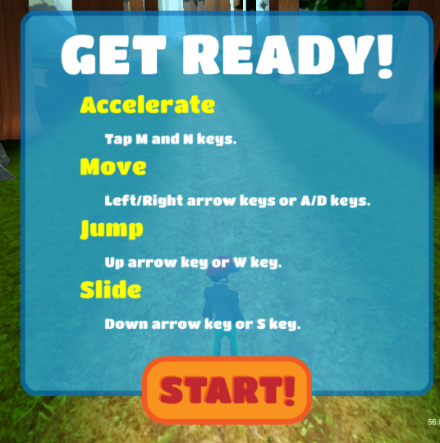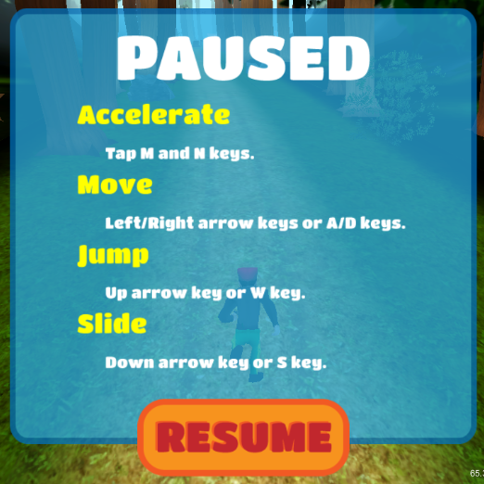 Start and help/pause menu

Environment

Paths

* The runner’s path is made of premade chunks of path that are placed in a pre-set order.
* Each chunk is made up of a path with obstacles, power ups, currency, and scenery elements. There is corresponding forest path “chunk” for every city path “chunk”. The corresponding chunks have the same path length and shape, as well as corresponding obstacles and identical currency and powerup placement.

Obstacles/Pickups

* Currency and powerups are identical in both urban and forest levels.
* Each obstacle has corresponding urban and forest versions. These obstacles are very similar in shape and function, but they are either urban or natural in appearance.
* 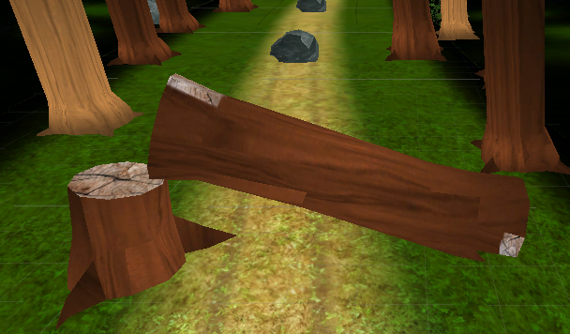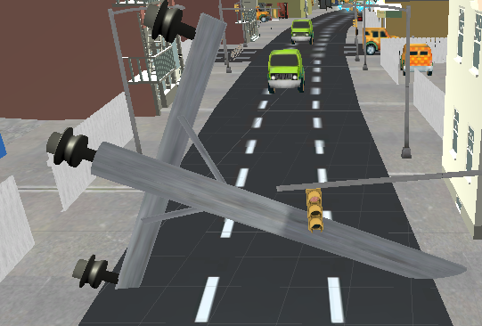
* 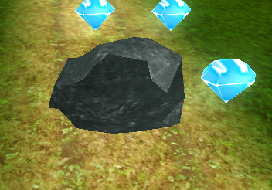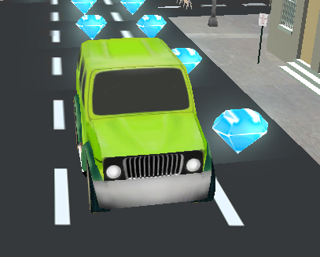
* 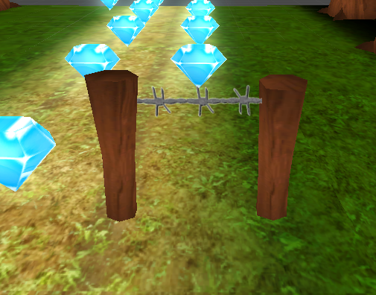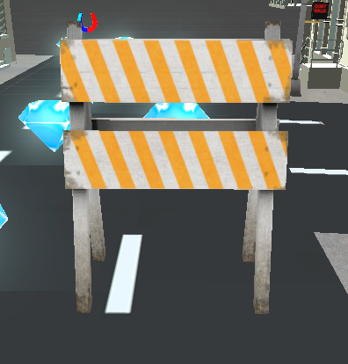
* 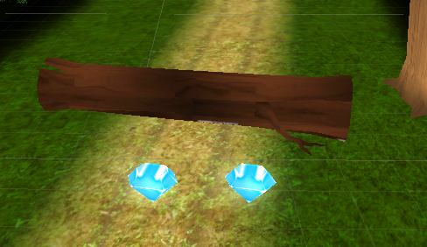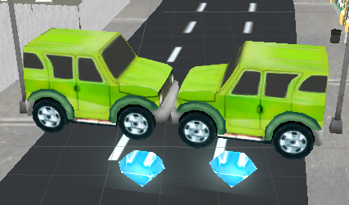

Sounds

* City ambient (https://freesound.org/people/Meepalicious/sounds/245890/download/245890__meepalicious__busy-passing-cars.wav, <https://freesound.org/people/Meepalicious/sounds/245890/>)
* Nature ambient (https://freesound.org/people/Soundholder/sounds/425368/download/425368__soundholder__ambient-meadow-near-forest-single-bird-and-eurasian-cranes-in-background-stereo-xy-mk012.wav, <https://freesound.org/people/Soundholder/sounds/425368/>)
* Footsteps that correspond with the speed of the player

Controls

* WASD and arrow keys for movement
* Obstacles can be dodged by moving left and right, jumped over or slid under

Player Character

* Dressed inoffensively like a jogger

Gameplay

Online vs Lab??

Logging